Component: Steering Rack

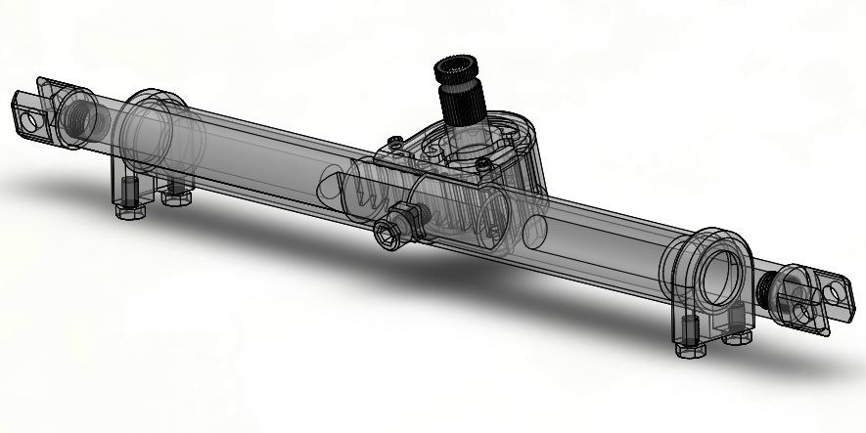

**Problem Identification**

1. What were the problems/disadvantages with previous part?
2. Which of these problems are the most important and why?

**Design Goals**

1. What are your strategies to solve the problems?
2. Could they produce downsides in other areas?
3. What is the “most beneficial” compromise?

**Design**

1. What was done in terms of the goals?
2. Any other information relevant to the design (stats, etc.)
3. Any validation?